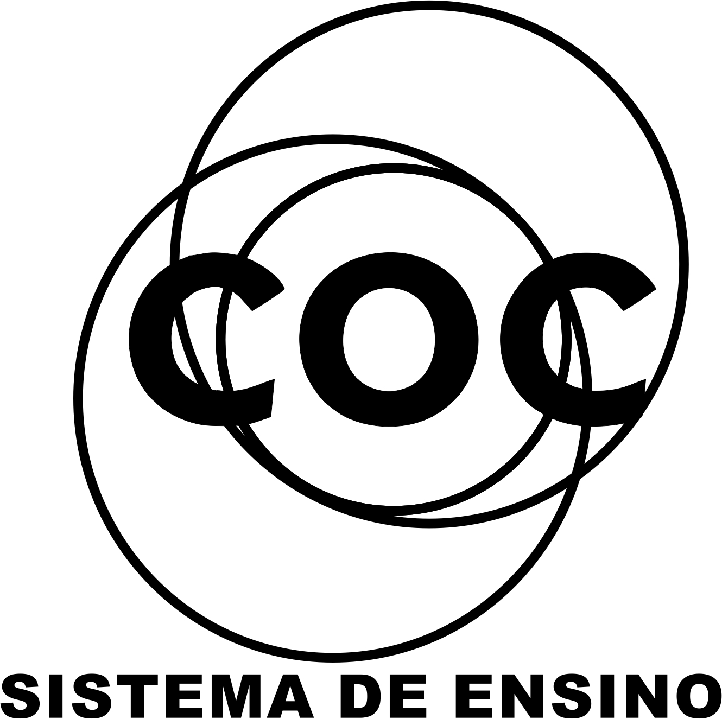

DATA: / / 2015

PROFESSOR (A):
LISTA DE EXERCICIO DE INGLÊS

SÉRIE:9º ANO
ALUNO (A): Nº:

TURMA:
NOTA:

3º BIMESTRE

From questions 5 to 8 say the correct idea of the modal verb (verb in bold).
Permission – ability - possibility – capacity – obligation – deduction – prohibition – moral obligation – advice/suggestion

01. Father to daughter: You can go to the party tonight.
__________________________________________

02. You should obey your parents.
__________________________________________

03 Charlie must be sick, he didn’t come to class today.
__________________________________________

04. It may rain tonight.
__________________________________________

05. Complete the sentences below with the present continuous tense.
a) Mary _________________________________ TV now. (to watch)
b) The boys ________________________________ video-games. (to play)
c) Mr. Johnson ________________________________ our exams. (to prepare)
d) We _____________________________ an English exam at the moment. (to take)

06. Use the simple present to complete the sentences below.
a) I usually ___________________________ to church on Sundays. (to go)
b) Betty never ___________________________ to church. (to go)
c) We _______________________________ every day.
d) He often _____________________________ on weekends. (to work)

07. Complete the sentences below using the present continuous tense or the simple present tense.
a) At present the Johnsons _____________________________ in France. (to live)
b) Listen! Rose ______________________________. (to cry)
c) I always ____________________________ movies on TV. (to watch)
d) He usually ______________________________ his clothes on Saturdays. (wash)

Read the text below and answer the questions that follow it in Portuguese. (Responda em português com base no texto abaixo)

THE TEACHER WAS WRONG

Thomas Edison was one of the most important American inventors. He produced 1,093 different inventions! Some of them were more practical and more famous than others: the phonograph (or record player), synthetic rubber, an electric motor, equipment for telephones, and his greatest invention, the incandescent lamp.
Edison had the genius to apply scientific principles to solve practical problems. He was a tireless worker, and modesty was one of his best qualities. “I am not a genius,” he often said. “Genius is one per cent inspiration and ninety-nine per cent perspiration,” he added, in a clear reference to the fact that he always had to work very hard to be successful.
But when Edison was 7 he didn’t like school very much. The other boys in his class were brighter than Tom. They were also cleaner and tidier than he was. There is a story however, that shows young Tom’s great intelligence. Tom often went to school with dirty hands and face. Once the teacher looked at him and said, “Tom, show mw your hand.” He spat on his hand, rubbed it on the seat of his trousers, then showed it. The teacher looked at Tom’s hand with a sad face. “Tom, if you can find another hand in the room dirtier than this one, I won’t punish you.”
Tom immediately showed her his other hand.

08. Quem foi Thomas Alva Edison?
__________________________________________________________________________________________________________________________________________________________________________________________ ______________________________________________________________________________________

09. Quando Edison foi considerado estúpido?
____________________________________________________________________________________________________________________________________________________________________________________________________________________________________________________________________________________________________________________________________________________________________________

10. Como Edison provou que a professora estava errada?
____________________________________________________________________________________________________________________________________________________________________________________________________________________________________________________________________________________________________________________________________________________________________________

11. Qual a maior invenção de Edison?
___________________________________________________________________________________________
___________________________________________________________________________________________
____________________________________________________________________________________________________________________________________________________________________________________________________________________________________________________________________________________________________________________________________________________________________________

Wiki Questions

At school we are doing a project on teenagers and their free time. We are collecting information from different countries. Can you help me? Thanks!
Sam, Massachusetts, US

After school we always meet in a café. We love chatting and we talk about everything – TV, music, and movies, our parents, people from school, and our plans for the weekend.
Toni, Choluteca, Honduras

On weekends, I often visit my friends at the shopping mall. We enjoy shopping but we don’t have much money, so we usually look in the store windows. I work in my uncle’s grocery store on weekends because I’m saving money to buy a cell phone.
Julia, Managua, Nicaragua

What free time? I don’t finish school until five o’clock. My friends and I have private classes in the evenings, too. I go online every day and I often visit this site. I sometimes ask questions but I rarely answer them. So, what am I doing right now? I’m answering this question!
Chan Ho, Seoul, Korea

I do volunteer work in my free time. At the moment, I am working at an animal shelter – a place for homeless animal. There are a lot of them in Brazil. I work for three hours every Saturday. On Sundays, I often go walking with our dogs. We have three.
Hugo, João Pessoa, Brazil

From questions 1 to 5 answer the questions in Portuguese according to the text
12.Quem tem um emprego remunerado no tempo livre?
____________________________________________________________________________________________________________________________________________________________________________________________________________________________________________________________________________________________________________________________________________________________________________

13. O que o Sam está fazendo na escola?
____________________________________________________________________________________________________________________________________________________________________________________________________________________________________________________________________________________________________________________________________________________________________________

14. Como o Sam está fazendo isso?
____________________________________________________________________________________________________________________________________________________________________________________________________________________________________________________________________________________________________________________________________________________________________________

15. Com o que o Hugo está trabalhando?
____________________________________________________________________________________________________________________________________________________________________________________________________________________________________________________________________________________________________________________________________________________________________________

16. O que o Tony gosta de fazer?
____________________________________________________________________________________________________________________________________________________________________________________________________________________________________________________________________________________________________________________________________________________________________________

WORLD SWEET WORLD 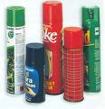

Supersonic Jet planes, hair spray, aerosol insecticides.
What do they have in common? We use them for completely different purposes. But they have a dangerous common effect. They damage the ozone layer of the atmosphere.
We talk a lot about the various forms of pollution: air pollution, water pollution, noise pollution, radioactive contamination, etc. but we don’t hear much about the damage to the ozone layer of the atmosphere.
Ozone is a gas. It has three atoms of oxygen per molecule of gas. But it is not a stable gas. When ozone is in contact with other gases, it gives one of its oxygen atoms to them. Then, it becomes ordinary oxygen. That is exactly where the problem begins.
The layer of ozone in the atmosphere is approximately 15 to 30 miles above the earth. It filters the sun light and absorbs much of the ultraviolet radiation. In short, it protects us of the ultraviolet radiation of the sun.
When ozone becomes oxygen, there is little protection against ultraviolet radiation. Oxygen does not block this type of radiation and we are consequently exposed to it. This radiation causes many types of skin cancer in man. It also affects plants and sea life.
Evidently, technology brings us comfort and progress. But the price is very high – it is destroying our environment. It makes our world more comfortable, but it also damages it; this is a serious problem and we have to face it.

VOCABULARY:
purpose- finalidade damage- causar danos hear- ouvir stable- estável give- dar ordinary- comum
above- acima little- puco(a) skin- pele happen- acontecer when- quando

17.What is the effect of aerosol insecticides on the atmosphere?
_________________________________________________________________________________________________________________________________________________________________________________________________________________________________________________________________________________

18. What are the various forms of pollution?
____________________________________________________________________________________________________________________________________________________________________________________________________________________________________________________________________________________________________________________________________________________________________________

19. What happens when ozone is in contact with other gases?
____________________________________________________________________________________________________________________________________________________________________________________________________________________________________________________________________________________________________________________________________________________________________________

20. When is there little protection against radiation?
____________________________________________________________________________________________________________________________________________________________________________________________________________________________________________________________________________________________________________________________________________________________________________

Art museums intimidate many adults. What about kids?

Now you have “With Open Eyes” ($39.95 Mac/Windows CD-ROM*) to make children feel at home with some of the world’s most famous images, like Edward Hopper’s “nighthawks”. The CD-Rom presents 212 objects from the Art Institute of Chicago’s collection in a clever graphical interface. Children can examine and spend funny moments with art through various activities. The audio bytes that accompany the presentation of the works can be irreverent, and there is no index of all works. This disc is not encyclopedic but it will teach young eyes how to see.

(Adapted from Newsweek, June 26, 1995)

*CD-ROM – Compact Disc-Read-Only Memory

VOCABULARY
NIGHTAWKS= falcões da noite CLEVER= inteligente
Answer in Portuguese. (responda em português)

21. Sobre o que é o CD-ROM?
____________________________________________________________________________________________________________________________________________________________________________________________________________________________________________________________________________________________________________________________________________________________________________

22. Qual o nome do CD-ROM?
___________________________________________________________________________________________

SHOPPING CENTRES (June 2009)
People in the western world spend a lot of time in shopping centres. Shopping centres are consumer paradises. They are climate-controlled, with wide arcades, fountains, plants and escalators.
Every type of shop can be found and, for the hungry shoppers who often drive long distances, fast-food shops are available. Even exquisite restaurants have opened in shopping centres.
Of course, no shopping centre today is complete without a cinema, showing several films simultaneously. Cinemas at shopping centres were initially to keep youngsters busy while their parents went shopping. In the past, some shopping centres did not show adult films for this reason.
Gradually, the shopping centre became the place for family meetings, with or without shopping. Families go there just to spend time together away from home.

23. Que tipo de atividades você pode fazer em um shopping centre?
____________________________________________________________________________________________________________________________________________________________________________________________________________________________________________________________________________________________________________________________________________________________________________

24. Por que as famílias vão aos shopping centres?
_______________________________________________________________________________________________________________________________________________________________________________________________________________________________________________________________________________________________________________________________________________________________________________________________________________________________________________________________________

Shopping centre = shopping center

PHYSICAL EXERCISE AND INTELLIGENCE

Intelligence is not a simple quality. It involves:

> the ability to learn;
> the ability to solve problems;
> the ability to think quickly.

Different people use these abilities in different ways in dealing with ideas and symbols, solving practical problems (fixing the washing machine, for example), and relating with other people.
One of the most effective way to stay mentally sharp is to keep the mind active – especially as we grow older.
Intelligence increases until the age of 26. It stabilizes until the age of 40, and then declines slowly.
A well-exercised mind uses less energy than an untrained one. One reason for this is that the brain adapts to mental training just like our muscles respond physical training.
A trained brain uses fewer neurons, just like fit muscles use less fibers to perform a task. As a result, less fuel (carbohydrates) is consumed and more efficiency is achieved.
And the mind, like the body, is able to do more with less effort. In short, although the combination of physical and mental activity is not the Fountain of Youth, it certainly is the best thing we can do to keep our intelligence sharp.

Based on www.earthden.org.
Accessed on May 2, 2010

25. O que a inteligência envolve?
____________________________________________________________________________________________________________________________________________________________________________________________________________________________________________________________________________________________________________________________________________________________________________

26. Qual a maneira mais eficaz de ficar mentalmente em forma?
____________________________________________________________________________________________________________________________________________________________________________________________________________________________________________________________________________________________________________________________________________________________________________

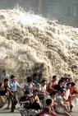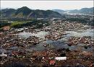

Tsunamis

On December 26, 2004, the world wondered at the images of one of the biggest and most devastating natural disasters in recent memory. A violent earthquake in the Indian Ocean of a magnitude of 9 on a scale of 1 to 12, initiated several tsunamis and hit Indonesia, Sri Lanka, India and Thailand, killing more than two hundred thousand people.
But what kind of phenomenon is this?
A tsunami is a chain of fast moving waves caused by sudden trauma in the ocean. They can be generated by earthquakes or volcanic eruptions. These destructive waves can move across the ocean as fast as a jet airplane – about 600 miles per hour (960 km/h). In deep waters the waves are a few feet high, but when they reach the shallow coasts, they can be over 50 feet (15 meters) high and devastate whole villages. Unfortunately we can’t stop them, but we can use a Tsunami Warning System to warm people of an imminent tsunami up to a few hours before it hits the coast.

27.Onde ocorreu o tsunami?
_____________________________________________________________________________

28. A que velocidade as ondas de um tsunami viajam?
_____________________________________________________________________________

29. A que altura as ondas de um tsunami chegam quando elas alcançam a parte rasa da costa?
_____________________________________________________________________________

Read the etxt below and answer the questions according to it in English. (Responda em inglês com base no texto)

Climate Change

The burning of coal, oil and natural gas, as well as deforestation and various agricultural and industrial practices, are altering the composition of the atmosphere and contributing to climate change. These human activities cause greater concentrations of particles and greenhouse gases in the atmosphere. Increased concentration of carbon dioxide and methane have a heating effect.

Answer in Portuguese according to the text:
30. What human activities are contributing to climate change?
____________________________________________________________________________________________________________________________________________________________________________________________________________________________________________________________________________________________________________________________________________________________________________

